**Southeast Asia needs more Cyber Security Specialists**

The covid-19 pandemic caused a massive global economic recession. It is the world's worst recession since World War II.**N1** To stay resilient, many industries such as food delivery, groceries, education, healthcare, entertainment, and so on, are shifting to online business models.

The pandemic has accelerated the pace of business digital transformation while also increasing the need for tech talents. However, the number of tech talent available is far less than the demand, resulting in a severe shortage.

“According to Microsoft, by 2025 there will be 149 million new technology-oriented jobs globally across privacy and trust, cybersecurity, data analytics, and cloud and software development”. **N2**

Many of the most promising tech unicorns, such as Tencent, ByteDance, Alibaba, Grab, Salesforce, Facebook, Google, and Amazon, have set up headquarters in Singapore, and they are looking to hire tech talent in Southeast Asia because of the region's young and growing population, as well as its affordability.

**Which Southeast Asian countries have the most Tech Talents?**

According to Linkedln data extracted in July 2021, among the six Southeast Asian countries of Indonesia, Singapore, Malaysia, the Philippines, Thailand, and Vietnam, Indonesia has the highest supply of tech talent 24% (1,873K). Singapore is second with 22% (1,685K), and the Philippines is third with 22% (1,660K).

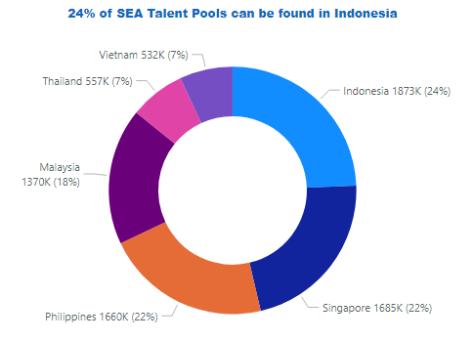

Since many large companies are hiring tech talent from Southeast Asia, there are some tech roles in short supply.

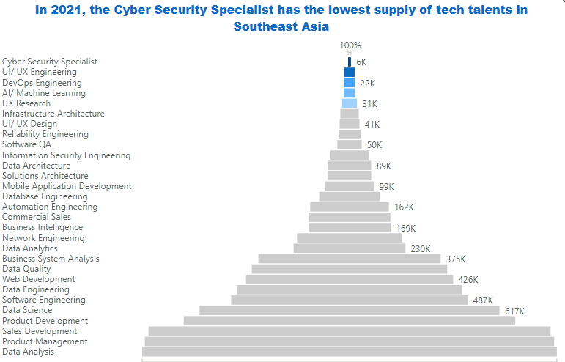

According to data extracted from Linkedln in July 2021, the top three tech talent roles with the lowest supply in Southeast Asia are Cyber Security Specialist (5,880), UI Engineering (22K), and DevOps Engineering (22K).

Let us now narrow our focus to the job role of Cyber Security Specialist, which has the lowest supply of tech talent.

**How many Cyber Security Specialists will be needed in 2025?**

As per data obtained from Linkedln in July 2021, there are only **5,880** Cyber Security Specialist Specialists in Southeast Asia. Cyber Security specialists increased by**3%** from 5,705 in May 2021 to 5,880 in July 2021. We will assume a 3% annual growth rate for the supply of Cyber Security Specialist.

While according to e-Conomy SEA, internet usage in Southeast Asia (SEA) has increased, with 40 million new users this year, and the SEA internet economy has evolved, with a forecast of $300 billion by 2025. It will grow by **24%** over the next five years, from 105 billion in 2020 to 309 billion in 2025.**N3**

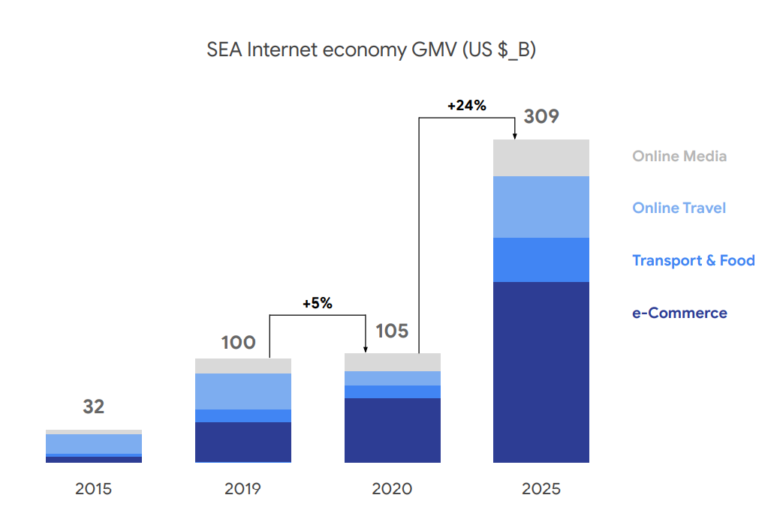

This chart was sourced from e-Cononmy SEA Report **N3**

The rapid growth of the internet economy will have a significant impact on the labor market. Comparing with the annual growth rate of talent supply of 3% and the e-Conomy SEA growth rate of 24% over the next five years which is approximately 4.8% growth rate per year, we forecasted a shortage of 616 Cyber Security Specialists in Southeast Asia by 2025.

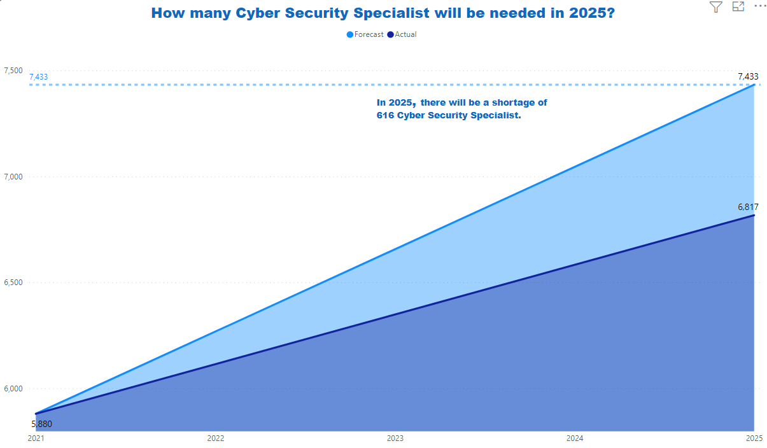

The shortage of Cyber Security Specialists is not limited to Southeast Asia. New York Times reported that there are 3.5 million open positions in cybersecurity available worldwide in 2021.**N4**

Not only that, but according to a Burning Glass study, the number of Cybersecurity job postings has increased by 94% in the last six years. In comparison, the overall number of IT jobs has increased by about 30%. When compared to the overall IT job market, this represents a 300 percent increase in demand. Cybersecurity jobs now make up 13% of all information technology jobs.**N5**

**Where to find Cyber Security Specialist in Southeast Asia?**

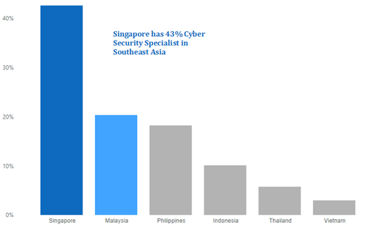

Singapore, as a regional tech hub, is a centre to many multinational corporations and banks. It also has the most Cyber Security Specialists (2,506 specialists) in Southeast Asia, followed by Malaysia (1,196) and the Philippines (1,071).

**What Can be Done?**

Cybersecurity will continue to grow as technology becomes digitally connected. The Internet of Things and cloud computing will have a significant impact on the growth of security threats. That means the need for skills to combat these problems will grow.

To address the talent shortage, companies can consider the following measures:

**1.** **When it comes to hiring, put skill ahead of degree**

One of the major causes of the shortage of Cyber Security Professionals is an overemphasis on degrees over skills. To close the skill gap, when hiring, people should focus on skills rather than degrees because technical skills can be learned quickly, as is a willingness to learn.

**2.** **Reskilling and Upskilling**

To ease the shortage issues, SEA companies need to beef up digital reskilling of their workforce. A good example is recently Microsoft has unveilved a number of digital reskilling programs across the Asia Pacific for students in Indonesia, Malaysia, Singapore and Thailand.

The company recently announced a partnership with SkillsFuture Singapore and the IMDA Singapore to equip 1,000 people with digital skills, as well as a commitment to train an additional 3 million Indonesians in digital future-ready skills.**N6**

**3.** **Support from big organizations in the form of free resources and training materials for the public.**

A good example will be IBM has introduced a wide range of options to close the skills gap. His new collar program introduced the first specialization for junior cybersecurity analysts, and Coursera has a certificate program available, with additional modules to be released this summer to create a complete certificate. **N7**

**4. Get Help from trusted recruitment partner**

Companies should consider partnering with a trusted recruitment partner to help them speed up the hiring process. Since the recruitment partner specializes in the industries and has access to a pool of talent, they can also improve hiring quality.

**5.** **Work alongside with local universities and institutions to close the skill gap**

Companies should consider collaborating with local education centers because they have a large pool of talented and enthusiastic people.

**Summary**

The pandemic transformed nearly every organization into a tech company. As a result, the shortage of tech talent has become a pressing problem for many companies.

With the growth of technology and internet usage, companies and internet users have become more vulnerable to cyberattacks. Therefore, the shortage of Cyber Security Specialists will be a serious issue, not only in Southeast Asia, but globally. It could result in the loss of hundreds of millions of dollars.

To address these issues, public and private sector collaboration is crucial in closing skill gaps and increasing the number of specialists in these areas.

**N1**[COVID-19 to Plunge Global Economy into Worst Recession since World War II (worldbank.org)](https://www.worldbank.org/en/news/press-release/2020/06/08/covid-19-to-plunge-global-economy-into-worst-recession-since-world-war-ii)

N2<https://sbr.com.sg/information-technology/in-focus/demand-tech-talent-surge-in-2021-study>

N3 https://drive.google.com/file/d/19HIybjomE455NifXvtyIvtawhbkKXh8e/view?usp=sharing

**N4**https://startup.info/cybersecurity-career/

**N5**https://www.ibm.com/blogs/ibm-training/new-cybersecurity-threat-not-enough-talent-to-fill-open-security-jobs/

**N6**<https://techwireasia.com/2021/03/apac-is-in-need-for-more-cybersecurity-experts/>

**N7**https://www.ibm.com/blogs/ibm-training/new-cybersecurity-threat-not-enough-talent-to-fill-open-security-jobs/